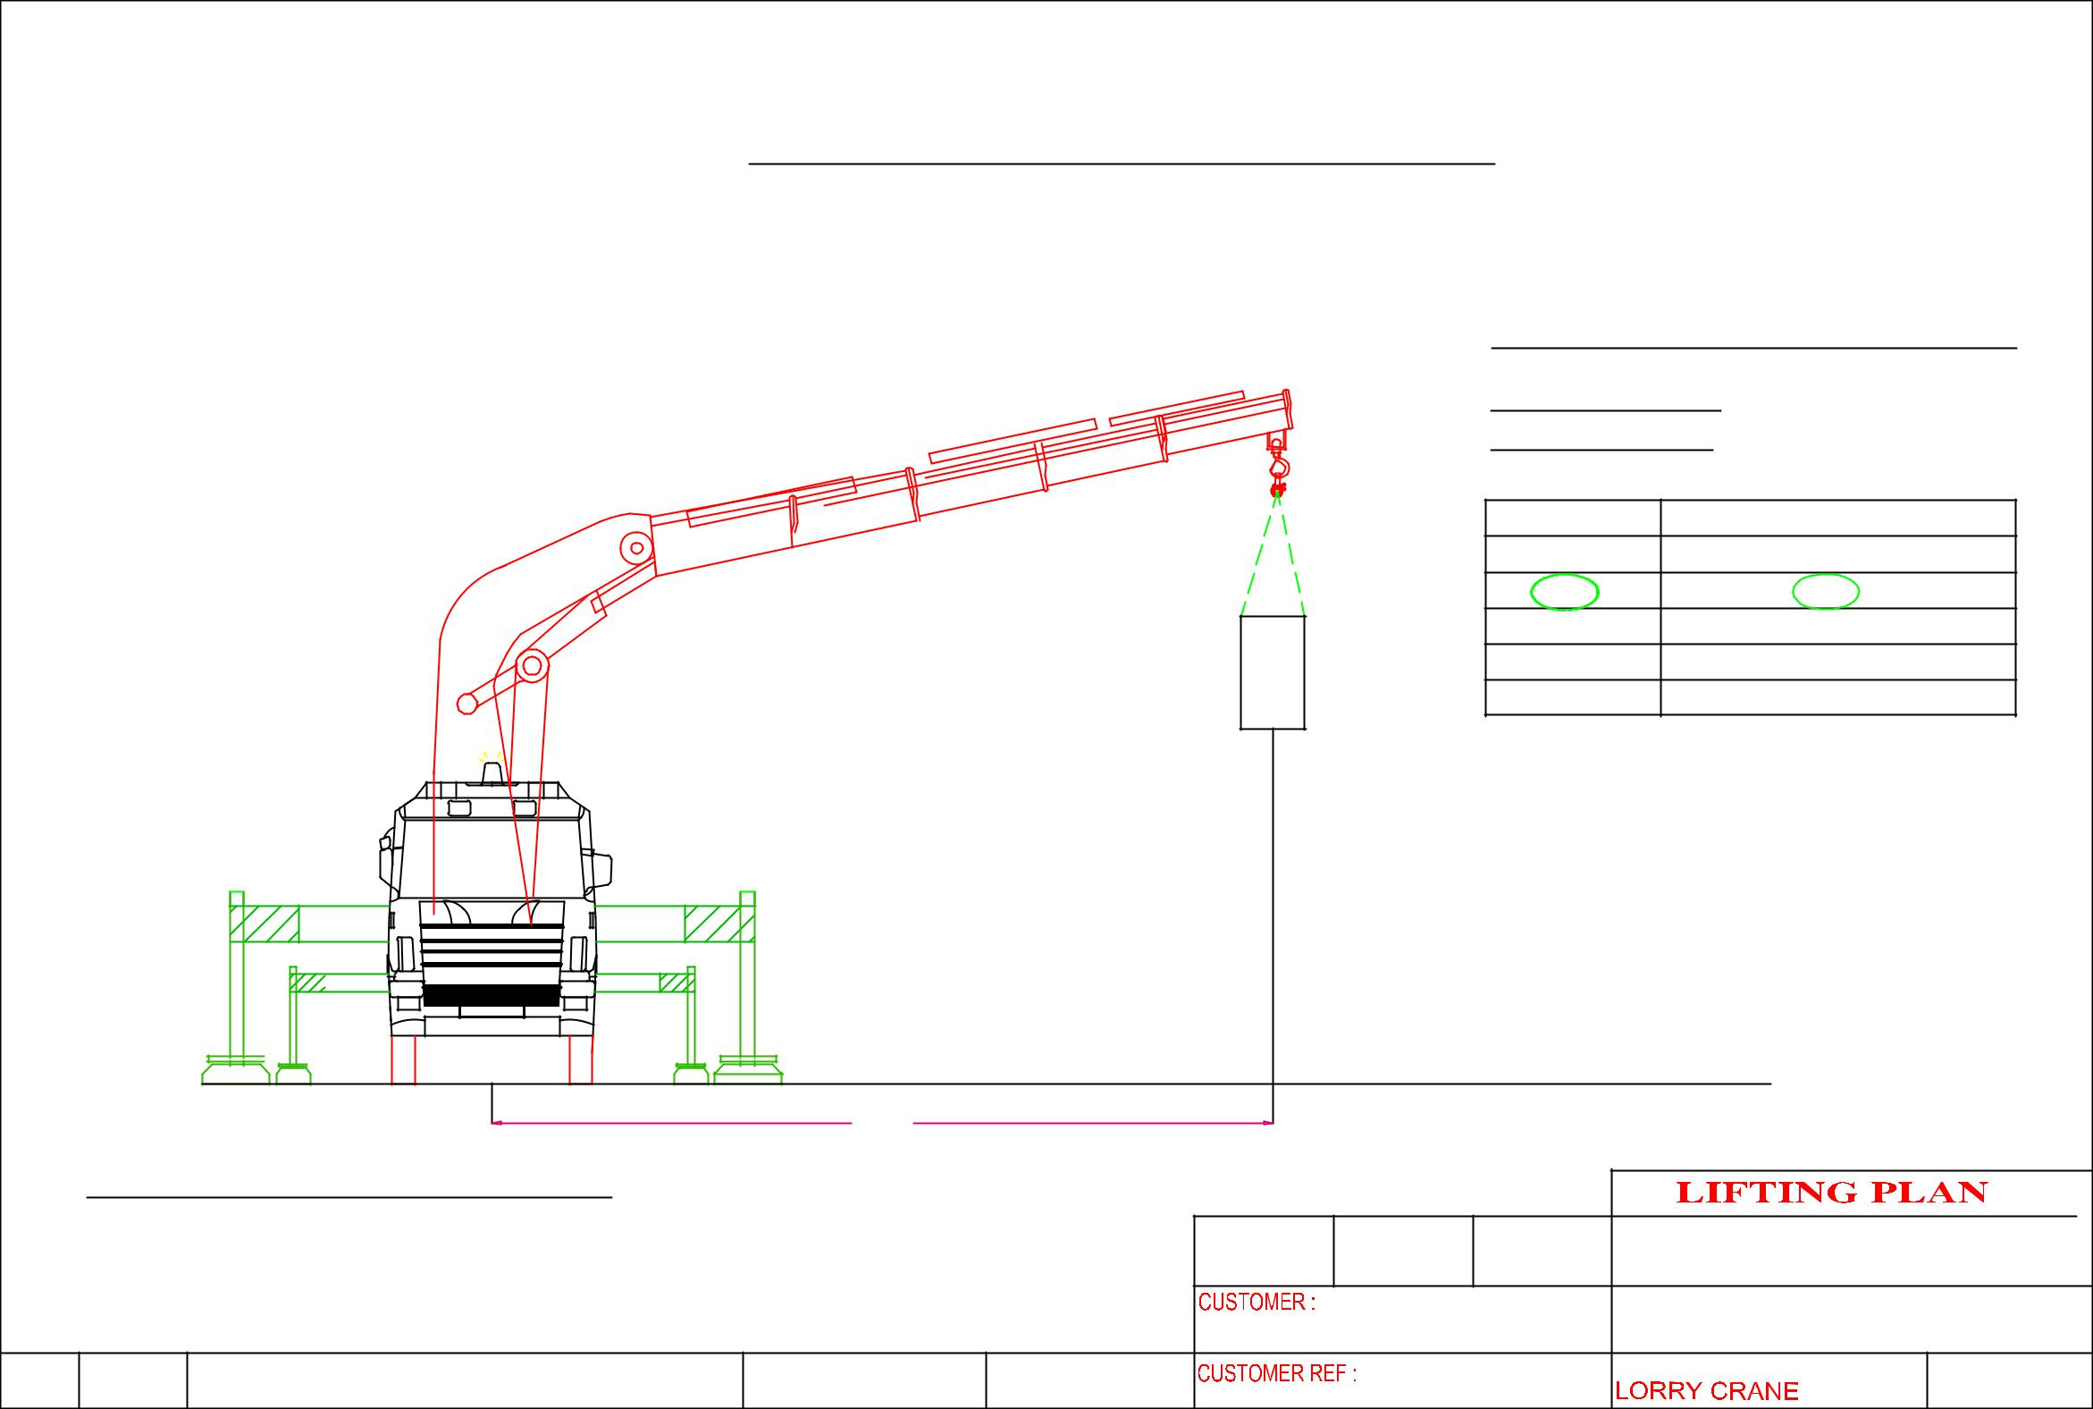
 |  |  | Hoisting machine @ 18 Tractor Rd
 |  |  |  |  |  |  |  | CRANE: PALFINGER PK92002SH
 |  |  |  |  |  |  |  | LORRY CRANE
 |  |  |  |  |  |  |  | CRANE CONFIGURATI0N
 |  |  |  |  |  | m6 |  | OPERATING RADIUS: 6m
 |  |  |  |  |  |  |  | ^{RADIUS (m)} |  | LIFTING CAPACITY OF CRANE IN KG
 |  |  |  |  |  |  |  | 4 |  |  | 16,900
 |  |  |  |  |  |  |  | 6 |  |  | 12,200
 |  |  |  |  |  |  |  | 8 |  |  | 9,100
 |  |  |  |  |  |  |  | 10 |  |  | 7,100
 |  |  |  |  |  |  |  | 12 |  |  | 5,700
 |  |  |  |  | MACHINE WEIGHT: | 3,000 KG |  | SAFETY FACTOR CALCULATION
 |  |  |  |  |  |  |  | WEIGHT OF CARGO |  |  | : 3, 300 KG
 |  |  |  |  |  |  |  | LIFTING ACCESSORIES WEIGHT : 50 KG
 |  |  |  |  |  |  |  | TOTAL WEIGHT OF LIFTING |  |  | : 3,350 KG
 |  |  |  |  |  |  |  | LIFTING CAPACITY |  |  | :12,000 KG
 |  |  |  |  |  |  |  | SAFETY FACTOR |  |  | : 3.5
 |  |  |  | 6000
 | CRANE: PALFINGER Pk92002SHH
 |  |  |  |  |  | DRAWN | APPROVED | DATE | ERIC WONG MACHINERY TRANSPORTATION P/L
 |  |  |  |  |  |  | NOK Precision Component (S) Pte Ltd |  | DRAWING NAME:
 |  |  |  |  |  |  |  |  | HOISTING OF MACHINE

